Date

November 3, 2017

Time

3:00-5:00 pm

Location

Gibbs Realty Main Office
4891D Hwy 153
Easley SC 29642

Cost

free

Registration

Registration is required to attend this training class.
Please register at wendy@gibbsrealty.net
Or call 864-414-8184

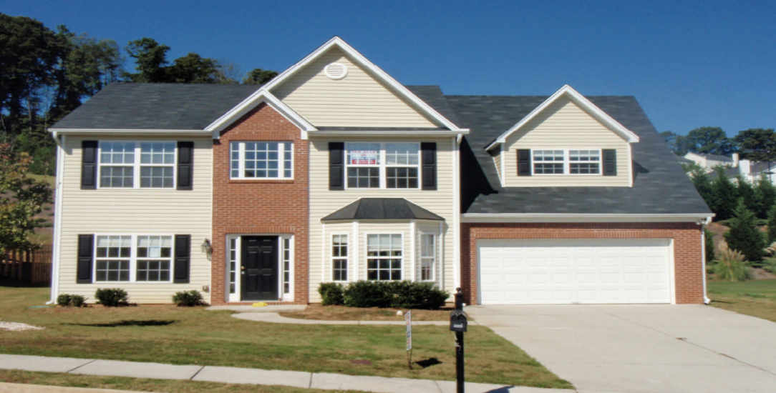

SUCCESSFULLY SELLING
HUD HOMES IN SC:

This class is presented to make you aware of the many changes
that have occurred in the HUD sales process in the new
3.7 contract and the appointment of the
new HUD Marketing Manager, KM Minemier and Associates.

Learn how to make the selling process simplified with DOCUSIGN signatures. No more FEDEX fees, wet signatures and eliminate most errors on the contract!

The class is being presented by Gibbs Realty, a HUD listing broker.
It is designed to help real estate agents understand the HUD sales
process whether you have sold HUD properties before or if
you are brand new to the process.

This is a 2-2.5 hour presentation with handouts.
Light refreshments will be served.
A Q&A session will be offered.

